**Host plant adaptation during recent global range expansion in the monarch butterfly**

**Abstract**

Herbivores that have recently expanded their host plant ranges provide an opportunity to test hypotheses about the evolution of host plant specialization. Here, we take advantage of the contemporary global range expansion of the monarch butterfly (*Danaus plexippus* L.) and conduct a reciprocal rearing experiment involving monarch populations with divergent host plant assemblages. Specifically, we ask the following main questions: (1) Do geographically disparate populations of monarch butterflies show evidence for local adaptation to their host plants? If so, what processes generate this pattern? (2) How is dietary breadth related to performance across multiple host species in monarch populations? (3) Does variation in performance differ across host species? We find evidence for local adaptation in larval growth rate and survival, driven by loss of performance of derived monarch populations reared on ancestral hosts. Migratory North American monarchs, which have comparatively broad host breadth, have higher mean performance than derived non-migratory populations across all host plant species. Monarchs reared on their sympatric host plants show lower performance variation than monarchs reared on allopatric hosts. The pronounced performance loss of derived populations on ancestral hosts highlights the potential importance of non-adaptive processes (especially relaxed selection) in generating patterns of host specialization.

**Keywords**: Range expansion, local adaptation, herbivory, monarch butterfly, diet breadth

**Introduction**

The vast majority of plant-feeding arthropod species exhibit narrow and highly specialized diets (Forister *et al.* 2015). Verbal and mathematical arguments often explain this restriction of dietary breadth in the context of cross-host performance tradeoffs (i.e. “the jack of all trades is the master of none” hypothesis) (Rausher 1984, Futuyma and Moreno 1988, Joshi and Thompson 1995). However, there is mixed emprical evidence to support this pattern. For instance, positive cross-host performance relationships—in which genotypes conferring a performance advantage on one host are postively associated with performance on another host—may be more common than perforance tradeoffs (Futuyma and Philippi 1987, Fry 1996, Agosta and Klemens 2009, Rasmann and Agrawal 2011, García-Robledo and Horvtiz 2012, Forister *et al.* 2012).

Performance tradeoffs are also central to hypotheses about local adaptation in populations of arthropod herbivores (Karban 1989, Via 1991, Agrawal 2000). Numerous studies have found evidence for local adaptation in plant-arthropod interactions, and in some cases local adaptation has evolved over as few as three generations (Karban 1989). However, many of these studies focus on relatively sedentary species such as wingless flower thrips (Karban 1989), spider mites (Agrawal 2000, Magalhāes *et al.* 2009), scale insects (Hanks and Denno 1994), or aphids (Via 1991). Definitions of local adaptation also differ between studies: some interpret GxE interactions broadly as evidence for local adaptation (Cogni and Futuyma 2009), while others use more specific criteria (e.g. ‘home vs. away,’ ‘local vs. foreign,’ or ‘sympatric vs. allopatric’ definitions of local adaptation) (see Kawecki and Ebert 2004 and Blanquart *et al.* 2013). Finally, even in cases where local adaptation is identified, many studies do not attempt to distinguish underlying mechanisms generating this pattern. Thus, we still have limited understanding for whether local adaptation to hosts in arthropod herbivores is driven primarily by antagonistic pleitropy (i.e. genotypic tradeoffs) versus conditional neutrality (i.e. genotypes that are beneficial on one host but selectively neutral on other hosts) (but, see Gompert *et al.* 2015, Gompert and Messina 2016).

Herbivorous insects that have recently expanded their geographic and/or host plant range provide valuable opportunities to address questions about the evolution of host plant adaptation and specialization (Feder *et al.* 1988, Carroll et al. 2005, Jahner *et al.* 2011, Bean *et al.* 2012, Gompert *et al.* 2015), especially in cases where the introduction history is well-known. In their newly-established range, herbivorous insects may adapt to novel species of host plants not encountered in the ancestral range (Louda *et al.* 1997, Van Klinken and Edwards 2002, Erbilgin *et al*. 2014), a more restricted set of hosts (either novel or ancestral) (Pateman *et al.* 2012), or an expanded range of host species that are ancestral, novel, or a mixture of both (Singer *et al.* 1993, Graves and Shapiro 2002). These scenarios result in different sets of predictions for how adaptation will proceed in the introduced range.

In instances where dietary breadth is reduced during range expansion, directional selection may increase performance on the subset of available host plants. This adaptation may come at a cost in performance on absent ancestral hosts, especially if there are strong cross-host performance tradeoffs. Tradeoffs are expected to be more likely if novel hosts are phylogenetically and chemically disparate from ancestral hosts (e.g. Pearse and Hipp 2009, Bertheau *et al.* 2010, Rasmann and Agrawal 2011). By contrast, in situations where range expansion involves no change or an increase in host plant breadth, we do not expect for a reduction in performance on ancestral hosts.

When herbivore populations are exposed to many or few hosts, we expect different outcomes of natural selection. Because spatial and temporal heterogeneity act to maintain genetic variance for fitness across environments (Gillespie and Turelli 1989, Kassen 2002, Chakraborty and Fry 2016), we predict that broad dietary breadth should promote maintenance of genetic variation for performance through balancing selection (Joshi and Thompson 1995). Second, dietary generalists might be expected to have larger effective population sizes (Packer *et al.* 2005, Li *et al.* 2014), which are also predicted to maintain genetic variation and performance across hosts (Whitlock 1996). Thus, on average, we expect higher mean performance across host species in herbivore populations with broader dietary breadth.

Several hypotheses involving host plant adaptation have been put forward based on mean performance across hosts, but we also predict that variance in performance should be lower for demes/populations reared on sympatric compared to allopatric hosts. Demes reared on novel/allopatric hosts could have high variation in performance, possibly due to expression of cryptic genetic variation (Schlichting 2008) or inappropriate expression of canalized responses under novel environments (Van Buskirk and Steiner 2009). For example, the classic experiments of Clausen, Keck, and Hiesey (1940) showed that high elevation clones of *Potentilla glandulosa* grown at sea level had much more variation in stem height and flowering time than clones grown at their elevation of collection, and *Lasthenia fremontii* genotypes showed broader hydrological niche breadths when exposed to novel low-competition environments (Emery and Ackerly 2014). However, this hypothesis has not been formally tested (to our knowledge) in plant-herbivore systems.

We chose to test these predictions in the monarch butterfly (*Danaus plexippus*, Danaidae: Danainae,L.), which has dramatically expanded its range over the last 180 years (Figure 1). Although best known from its ancestral range in North America, the monarch can now be found in locations around the world, where it forms geographically isolated, generally non-migratory, year-round breeding populations. In most cases, establishment dates for these populations are well-documented, with a wave of out-of-North America expansion taking place over the last ~180 years (Vane-Wright 1993, Zalucki and Clarke 2004). It is thought that the monarch’s establishment in these locations is due to human-mediated introduction of host plants. However, the monarch’s introduction dates and population genetics are consistent with a natural wave of expansion (Pierce *et al.* 2014a, Zhan *et al.* 2014, Hemstrom and Freedman in prep). In most locations where the monarch has become established, it has highly restricted dietary breadth and often feeds on evolutionarily novel host species (see ‘Background’).

Here, we use the monarch’s recent global range expansion to test ideas about host plant adaptation. We address the following three questions about monarch performance (see Figure 2): (1) *Do monarch populations show local adaptation to their host plant assemblages?* (2) *Do monarch populations with broader dietary breadth have higher mean performance across hosts?* (3) *Is variation in performance lower in sympatric host plant x monarch population combinations?* We test these questions using a common garden approach by raising monarchs from different populations on a variety of ancestral and novel host plant species.

**Methods**

*Background*

**Timing of range expansion**: Monarchs became established on many Pacific Islands beginning approximately 180 years ago, with the first conclusive records coming from Hawaii in 1841 (Vane-Wright 1993). They then moved southwestward across the Pacific in a stepwise fashion, eventually becoming established in Australia in 1871 (Vane-Wright 1993, Zalucki and Clarke 2004). Another population became established in the Mariana Islands (including Guam), with the first records coming from 1887 (pers. obs., British Natural History Museum); the Guam population represents an independent out-of-Hawaii expansion (Hemstrom and Freedman, in prep). Finally, in a separate out-of-North America expansion, monarchs established in the Caribbean, including Puerto Rico (Zhan *et al.* 2014). The timing of the monarch’s establishment in Puerto Rico is less certain but likely occurred thousands of years ago (Figure 1). Puerto Rican monarchs are treated as their own subspecies, *D. plexippus portoricensis* (Ackery and Vane-Wright 1984) and are phenotypically distinctive from North American *D. plexippus plexippus*.

**Host plant associations in novel range**: Monarchs that colonize novel areas like tropical islands become non-migratory and have access to only one or two species of milkweed host. This is in contrast to the ancestral North American monarch population, whose seasonal migration brings it into contact with more than 100 species of native *Asclepias* (Apocynaceae: Asclepiadoideae) hosts (Woodson 1954), 34 of which have been documented as host plants (Malcolm and Brower 1986). Derived non-migratory monarch populations are often exposed to evolutionarily and chemically novel host plants. For example, the monarch’s primary host plants in parts of Australia are *Gomphocarpus physocarpus* and *G. fruticosus* (Oyeyele and Zalucki 1990), and the primary hosts in the Hawaiian islands are *G. physocarpus* and *Calotropis gigantea* (Pierce *et al.* 2014b) (Figure 1; Table 1). All of these non-*Asclepias* hosts are native to subtropical Africa and India and have only recently become established outside of these areas. Many derived non-migratory monarch populations are also associted with tropical milkweed (*A. curassavica* L.); the geographic origin of this species is uncertain but is believed to be in Central or South America (Woodson 1954).

*Host plant propagation*

Seeds of six species of milkweed were collected with permits from around the world between 2015-2018. Milkweed species were chosen in accordance with (1) their prevalence as host plants for monarchs from each region and (2) to maximize representation within the milkweed phylogeny (see Agrawal and Fishbein 2008 and Appendix 1). When possible, seeds were collected by fruit, which ensures full-sib relatedness among fruit-mates due to their pollination biology (Wyatt and Broyles 1994). Seeds were stored either at room temperature or were cold stratified, depending on their germination requirements. In 2017, we used only four milkweed species (*Asclepias fascicularis* [ASFA – Western North America], *Asclepias syriaca* [ASYR – Eastern North America], *Asclepias curassavica* [ASCU – Guam], *Gomphocarpus physocarpus* [GOPH – Australia and Hawaii]); in 2018, we grew the same four species as well as two additional species (*Asclepias speciosa* [ASPEC – Western North America], *Asclepias incarnata* [AINC – Eastern North America]) (Table S2).

Beginning in February (2017) and March (2018) through September, plants were grown from seed and transplanted into 1 gallon plastic pots in UC Soil Mix media, in two greenhouses. Large pots and fertilization produced large plants capable of supporting multiple caterpillars, a situation sometimes encountered in the field (pers. obs.). Plants (N=634 total across years) were grown in a completely randomized design under ambient light (long days) and at 28**°**C in the same two greenhouses. Approximately one quarter of plants (157/634) were used in multiple feeding trials during the experiment because of limited sample sizes in some species; in these cases, we waited at least three weeks before applying new caterpillars to a plant that had already been used in a feeding trial. Plant ID was included as a random effect in all analyses to account for position and prior feeding effects (see below).

Across both years, plants were subject to low levels of common greenhouse pests, particularly flower thrips, green peach aphids, spider mites, and whiteflies. In 2017, oleander aphids (*Aphis nerii*) became established in both greenhouses. To control these aphids, in early June, plants were submerged in a dilute solution of water with castile soap (Dr. Bronners) to dislodge aphids, then promptly rinsed.

*Monarch butterfly collection*

Monarchs from 16 sites were collected with permits as live adult females from their respective locations and transported to Davis, CA in glassine envelopes (Table S3). In some cases, adults could not be collected in sufficient numbers, and so larvae were collected and reared to eclosion instead. In these cases, larvae were collected over a broad spatial (i.e. separate plants and separate sites) and temporal range (i.e. different developmental stages) to minimize the chance of sampling full or half sibs. Monarchs were kept alive as adults in glassine envelopes and fed a 5:1 water : honey mixture daily. For adult butterflies reared from larvae, we used hand-pairing to achieve mating within populations (Clarke and Sheppard 1956), with care taken to minimize the chance of crosses between potential sibs (Mongue *et al*. 2016). Field-collected adult females used for oviposition were sometimes infected with the protozoan parasite *Ophryocystis elektroschirrha* (OE)(Table S3), with infection rates generally reflecting those that occur in natural populations. In 2017, we used butterflies from four populations (eastern North America [ENA], western North America [CA], Hawaii [HI], Australia [AU]); in 2018 we used the same four populations as well as two additional populations (Guam [GU] and Puerto Rico [PR]) (Table S3).

Adult females were set up in oviposition cages with *A. curassavica* for ~24 hours to produce eggs that were used in the experiment, and females typically produced 20-100 eggs per 24 hours. Eggs were collected at the end of each 24 hour period and transferred to labelled petri dishes with a damp paper towel and a small number of *A. curassavica* leaves. These petri dishes were then stored either in the greenhouse or a lab benchtop, with water added as necessary to prevent leaves from drying out. As soon as the eggs reached the “black head” stage (*Zalucki et al.* 2001), petri dishes were checked every 12 hours for emergence, and within 24 hours of hatching, neonates were transferred onto their respective experimental host plants.

*Experimental design and data collection*

We reared caterpillars in a fully factorial design, with all monarch populations reared on all potential host species. When possible, we further stratified this design across individual maternal families. Because of the logistical challenges associated with having all populations developing concurrently, the experiment was carried out over the course of approximately three months in both 2017 and 2018. Since host plants were also continuously growing and potentially changing in condition during this time frame, we reared at least one monarch population over the duration of the experiment in both years in an attempt to account for possible temporal effects (see Figure S1) and also included a model term for plant age in all statistical analyses (see below).

As soon as neonates hatched, they were randomly assigned to an individual plant. We placed between 1-5 neonates per plant depending on their availability, though 85% of plants received the full complement of five neonates (see Table S4). Neonates were transferred with a fine paintbrush onto newly expanded leaves at the top of each plant. Plants were then fully enclosed using custom-made polyester Super-Aire™ sleeves (A-Roo LLC), with the bottom end sealed using a metal twist tie and the top sealed with binder clips (see Figure S2). In total, we set up approximately 4,000 neonate caterpillars over the course of the experiment.

Neonates were left to grow for eight days and then scored for survival and weighed; almost all larval mortality in monarchs occurs within this window (Zalucki and Malcolm 1999, Zalucki *et al.* 2001). Any surviving larvae that could be found were put into petri dishes and weighed to the nearest milligram. Larvae that could not be found were assumed to have died during their early development; in some cases we found the remains of first instar caterpillars (Figure S2). If plants were large enough, all surviving larvae were returned. If not, we used a random number generator to select which larvae to return to the plant.

After caterpillars reached their fifth and final instar, plants were checked daily to capture dates of pupation. Pupae were transferred into individually labeled 16 oz containers; on the day of eclosion, adult butterflies were kept in the container in which they eclosed for 6-8 hours to allow their wings to dry, at which point they were transferred into a glassine envelope. We recorded the mass of these newly eclosed adults and later measured forewing length, width, area, aspect ratio, and roundness, as well as hindwing area (for methods, see Freedman and Dingle 2018) and levels of adult cardenolide sequestration (Freedman and Vannette, in prep).

In total, we analyzed the following performance metrics: (1) larval survival and (2) mass on day eight, (3) time to pupation, (4) time to eclosion, (5) mass at eclosion, (6) adult wing morphological characteristsics, and (7) adult cardenolide sequestration. Larval survival has clear fitness implications. Mass on day eight, time to pupation, and time to eclosion are all related to development rate and were highly correlated with each other. We expect for natural selection to favor faster development rates, as this shortens the window when larvae are most susceptible to abiotic (heat, cold, rainfall) and biotic (predators, parasitoids, pathogens) sources of mortality. Eclosion mass and adult wing morphology may infuence fecundity and/or dispersal ability, while cardenolide sequestration ability may reflect distastefulness to potential predators.

*Plant Trait Sampling*

We sampled two plant defense traits to see if they could explain variation in performance. We measured latex production and cardenolide concentration, since these have been shown to be important determinants of larval monarch growth and survival (Zalucki and Kitching 1982, Zalucki *et al.* 2001, Agrawal *et al.* 2015). Immediately prior to adding neonate caterpillars, most plants (n = 565 / 634) were sampled for constitutive levels of latex production. We also collected leaf discs to measure constitutive levels of cardenolide production for 163 plants using the methods outlined in Zehnder and Hunter (2007). For full details on latex and cardenolide sampling, see Appendix 2.

*Statistical analysis*

*Question 1: Do monarch populations show local adaptation to their host plant assemblages?*

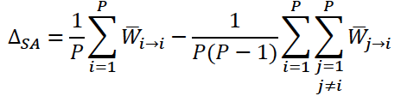 To quantify local adaptation, we use the approach outlined in Blanquart *et al.* (2013), which models the residual variation in performance after accounting for inherent differences among environments (*i.e.* milkweed species) and demes (*i.e.* monarch populations) (see Figure 2). Briefly, this approach summarizes local adaptation according to:

where Δ*SA* captures the difference in performance between all combinations of monarch populations on their sympatric milkweed hosts (Wi➔i) versus all combinations of monarch populations on their allopatric milkweed hosts (Wj➔i) (Figure S3). We fit linear and generalized linear mixed effects models that included fixed effects for milkweed species and monarch population of origin and a term for sympatric/allopatric status that describes the magnitude of local adaptation. Models were fit using the lme4 package version 1.1.21 (Bates *et al.* 2015) in R version 3.4.4 (R Core Team). In all models, we included the following terms as covariates: greenhouse, plant usage (first or second exposure to caterpillar feeding), plant age, and experiment year. In models using performance information from adult butterflies, we included infection status with the parasite OE and butterfly sex as covariates. In all models, we included random intercepts for plant ID nested within plant maternal family of origin, monarch maternal family, and greenhouse block. For a full summary of statistical models used, see Table S5.

For all continuous performance metrics (larval mass at day eight, days to pupation, days to eclosion, mass at eclosion, adult wing morphological measures), we fit models with Gaussian error distributions. In the model using larval mass at day eight as a response variable, we log transformed this measure to account for the non-linear accumulation of larval mass through caterpillar development. For ease of interpretation, we report larval mass results using back-transformed values, which therefore represents the geometic rather than the arithmetic mean. Because time to pupation and time to eclosion were almost perfectly correlated (R2 = 0.945), we only report results for time to eclosion. For larval survival to day eight, we fit a model with a binomial error distribution. All results were summarized using type II analysis of variance in the package ‘car’ v3.0.2 (Fox and Weisberg 2011). We also calculated marginal means in the package ‘emmeans’ v1.3.4 (Lenth 2019) and report these throughout the text.

*Question 2: Do monarch populations with broader dietary breadth have higher mean performance across hosts?*

To answer this question, we used exactly the same model structure as above. However, instead of treating each monarch population separately, we grouped populations according to whether they are ancestral (eastern and western North America) or derived (Hawaii, Guam, Australia, Puerto Rico). Ancestral populations have broad dietary breadth, while derived populations have narrow dietary breadth.

*Question 3: Is variation in performance lower in sympatric host plant x monarch population combinations?*

To analyze variance in performance, we calculated the coefficient of variation (CV = σ2/μ) in performance for each maternal family x plant genotype combination (n = 717). Here, any plants with only a single neonate added (n = 5) or with no surviving larvae at day eight (n = 24) were excluded from analysis, since no standard deviation of performance could be calculated for these plants. We then treated the remaining 688 plant-level coefficients of variation as response variables and used the same statistical framework as described above to determine how host plant species, monarch population, and sympatric/allopatric status affected variation in performance. Here, we focus only on larval mass at day eight as a metric for measuring variation in performance, since this was the only continuous measure for which we had sufficient sample sizes to measure plant-level CVs. In contrast to analyses of mean larval performance, for which we separately analyzed larval mass and larval survival, here we assigned larvae that did not survive a mass of 0 and included these zero values when calculating CVs.

**Results**

*Question 1: Do monarch populations show local adaptation to their host plant assemblages?*

For performance metrics associated with larval growth rate and survival, monarchs exhibited a pattern of local adaptation, indicated by significantly higher performance on sympatric compared to allopatric host plants. This effect was detectable, despite substantial variation in performance owing to inherent differences among host plants and monarch populations.

Host plant identity was by far the biggest source of variation in larval monarch performance (χ² = 69.65, DF = 5, p < 0.001). The host plant species in this experiment may encompass up to 40-50 MY of divergence (note: this estimate is uncertain, see Fishbein et al. 2011) and employ disparate defense strategies against larval monarchs. For example, our host species differed more than 20-fold in latex production and 50-fold in cardenolide production (Figure 3). In general, larval performance was lowest on milkweed species with high latex production. All populations performed worst on *A. speciosa*, which also had the highest latex production of the species tested. By contrast, monarchs tended to perform well on milkweed species with high cardenolide concentrations (*A. curassavica* and *G. physocarpus*).

For larval mass on day eight, monarchs reared on their sympatric hosts (x̅ = 237 mg) were over 16% larger than monarchs reared on their allopatric hosts (x̅ = 198 mg) (χ² = 15.74, DF = 1, p < 0.001). There were strong differences in day eight larval mass among host plants (χ² = 69.65, DF = 5, p < 0.001), with a 3-fold mass difference between *Asclepias curassavica* (x̅ = 343 mg) and *A. speciosa* (x̅ = 102 mg). Monarch population also explained a substantial portion of variation (χ² = 32.51, DF = 5, p < 0.001), with the highest mass in monarchs from eastern North America (x̅ = 320 mg) and lowest mass in monarchs from Puerto Rico (x̅ = 123.7 mg) (Figure 3a). Monarch populations from Australia and Hawaii, which are associated with a novel host (*G. physocarpus*), had no performance advantage on this host relative to populations naïve to this host (Figure 4a). By contrast, monarchs from areas with only derived hosts had sharply reduced performance on their ancestral North American hosts relative to ancestral North American populations (Figure 4a). Thus, the signal of adaptation appears to come from a loss of performance of recently range-expanded populations on ancestral hosts.

Survival on sympatric host plants was slightly higher (79.7%) than survival on allopatric hosts (75.7%) (χ² = 3.98, DF = 1, p = 0.046). Milkweed species again explained the largest proportion of variation in survival (χ² = 23.12, DF = 5, p < 0.001), with highest survival on *A. incarnata* (85.3%) and lowest survival on *A. speciosa* (68.8%). Differences in survival among populations were more modest (χ² = 12.17, DF = 5, p = 0.033) (Figure 4b).

Time to eclosion was faster for monarchs reared on sympatric host plants (x̅ = 22.5 days) compared to monarchs on allopatric hosts (x̅ = 22.8 days) (χ² = 4.81, DF = 1, p = 0.028). As with larval mass on day eight, milkweed species explained the largest proportion of variation in time to eclosion (χ² = 62.71, DF = 5, p <0.001), with time to eclosion fastest on *A. curassavica* (x̅ = 21.4 days) and slowest *on A. speciosa* (x̅ = 24.5 days). Monarch populations also differed in time to eclosion (χ² = 30.80, DF = 5, p <0.001), with eclosion occurring fastest for eastern North America (x̅ = 21.5 days) and slowest for Puerto Rico (x̅ = 23.7 days) (Figure 4c).

We did not find a signature of local adaptation in adult biomass or forewing area, nor strong differences among populations (χ² = 9.83, DF = 5, p = 0.080) or milkweed host species (χ² = 8.98, DF = 5, p = 0.110). There was also no sympatric/allopatric effect for adult eclosion mass (χ² = 0.00, DF = 1, p > 0.9). Adult eclosion mass and wing area were highly correlated (Figure S4), though population-level differences were more pronounced for forewing area than for eclosion mass (Table S5), reflecting migratory status. Our results show that selection from host plants is acting primarily at the early stages, with large effects on early instar survival and also development time.

*Question 2: Do monarch populations with broader dietary breadth have higher mean performance across hosts?*

In comparing ancestral and derived populations as groups, we found that ancestral North American populations, which have broad dietary breadth, had significantly higher mean growth rates across all host species (χ² = 10.45, DF = 1, p = 0.001). However, we did not find significantly higher overall survival in the ancestral North American populations (χ² = 1.41, DF = 5, p = 0.234). Time to eclosion was faster in ancestral populations (χ² = 10.42, DF = 1, p = 0.001) (Figure 4c), and ancestral populations tended to have higher eclosion mass than derived populations at eclosion (χ² = 2.78, DF = 1, p = 0.095) (Figure 4d).

*Question 3: Is variation in performance lower in sympatric host plant x monarch population combinations?*

Monarchs reared on their sympatric hosts had less variable mass of day eight than monarchs reared on their allopatric hosts (χ² = 4.53, DF = 1, p = 0.033) (Figure 5c). This result did not change if we used randomization tests to equalize the number of maternal families tested per monarch population (Appendix 3). Milkweed species was the strongest predictor of variation in performance (χ² = 24.77, DF = 5, p <0.001, Figure 5a). This result was driven by low variation in performance on *A. incarnata* (CV = 0.691) and *A. curassavica* (CV = 0.791) relative to other milkweed species, particularly *A. syriaca* (CV = 0.989). By contrast, monarch populations did not differ significantly in their CV (χ² = 7.79, DF = 5, p = 0.168, Figure 5b).

**Discussion**

We found evidence for local adaptation to host plant assemblages in monarch butterflies, with better larval performance (growth rate and survival) on sympatric compared to allopatric hosts. This result is consistent with our predictions and suggests that divergent selection pressures across the monarch’s global range have resulted in local adaptation to host plant assemblages over contemporary time scales (~1000 generations). Our local adaptation pattern was driven by primarily by poor performance of derived populations reared on their ancestral hosts. By contrast, derived populations had little or no performance advantage over ancestral naïve populatons on the novel host plants with which they now associate. Our data suggest that after ~1000 generations, population-level differences in monarch performance are driven not by directional selection for increased performance on novel hosts, but instead by relaxed selection and decreased performance due to loss of association with ancestral hosts.

Our findings are similar to those reported by Gompert *et al.* (2015) and Forister *et al.* (2009) in their studies of novel host plant utilization in *Lycaeides melissa* butterflies: *L. melissa* populations that utilize alfalfa as a novel host resource have a slight performance advantage on alfalfa relative to naïve *L. melissa* populations that feed on the ancestral host (*Astragalus*), but alfalfa-associated populations show a marked decrease in performance when returned to the ancestral *Astragalus* host plant. The loss of performance by derived populations on ancestral hosts suggests that neutral evolutionary processes (e.g. relaxed selection) may be an important component of host plant specialization (Hardy *et al.* 2016), especially under circumstances where derived populations become fully reproductively isolated from ancestral populations. Relaxed selection could drive the breakdown of enzymatric machinery or of behaviors that enable growth and survival on ancestral hosts, such as leaf notching or trichome shaving (Agrawal 2017). Our result is also consistent with the idea of local adaptation being driven by loci with conditionally neutral, rather than antagonistically pleiotropic, effects across hosts (Gompert *et al.* 2015), although formally demonstrating this pattern would require a genome-wide survey of fitness effects across many loci. Further experiments using additional monarch populations and/or populations from other independent out-of-North America expansions are needed to formally test how (1) time since establishment and (2) degree of genetic differentiation might be associated with performance on ancestral hosts.

Monarch population identity was a major source of variation in larval performance, with the ancestral North American populations consistently outperforming derived populations, regardless of host plant identity. This result is consistent with our prediction that populations with broader host plant breadth should have higher mean performance across the full range of hosts. However, because of the relatively small number of populations (n = 6) and independent range expansions (n = 2) that we tested, it is difficult to determine exactly why we saw this pattern. For example, host plant breadth is necessarily conflated with migratory status and effective population size in our study: only the large, migratory North American populations have access to diverse assemblages of host plants. This is reflective of a broader issue in studies of herbivore dietary breadth: generalist populations and species often have larger geographic ranges and population sizes (Janz and Nylin 2008, Jahner *et al.* 2011, Slove and Janz 2011). Thus, the higher mean performance across hosts that we observed in the ancestral North American populations could be explained by the maintenance of genetic variation for performance in migratory populations with broader dietary breadth, but it could also be explained by inbreeding depression in derived lineages with smaller population sizes.

We did not find evidence for local adaptation in the adult performance metrics (eclosion mass, wing morphology) that we tested. However, we did find modest population-level differences in eclosion mass and strong population-level differences in adult forewing area that correspond to differences in migratory status. Migratory North American populations generally had higher body mass and significantly larger forewings than derived non-migratory populations, consistent with other studies of trait divergence in migratory vs. non-migratory monarchs (Altizer and Davis 2010, Li *et al.* 2016). The absence of a local adaptation effect for these measures could reflect a developmental threshold pattern in monarch larvae, whereby pupation occurs after larvae have reached a predetermined size that is host plant invariant. Futhermore, it is possible that we would have detected local adaptation had we measured other aspects of adult monarch performance, such as longevity or lifetime fecundity (Scheirs *et al.* 2005).

We predicted that monarchs reared on their sympatric host plants would show reduced variation in performance relative to monarchs reared on allopatric hosts, and we did find this to be the case. This result is consistent with other studies that have found greater performance variation in species transplanted outside of their realized niche (e.g. Emery and Ackerly 2014), although to our knowledge this represents the first such demonstration in a plant-herbivore system. We also found that the coefficient of variation (CV) in performance was significantly different between milkweed species. Species-level differences in CV in performance were driven primarily by low levels of variation in *A. incarnata* and *A. curassavica*. These two species also happened to have the lowest latex production of any of the species tested. By contrast, the species with the highest latex production, *A. speciosa* and *A. syriaca*, also had the highest performance CV. These results suggest that latex production may be important for explaining performance variation among monarch families and accord with previous findings that latex production is the primary driver of larval mortality in monarchs (Zalucki *et al.* 2001).

Local adaptation to host plants is a central part of hypotheses about macroevolutionary patterns of specialization and speciation in herbivores (Janz and Nylin 2008). Our results provide an example of local adaptation developing over contemporary time scales in a highly mobile insect herbivore with a well-characterized range expansion history. Furthrmore, we show that local adaptation to host plants in this system does not seem to be strongly driven by cross-host tradeoffs, even in cases where monarchs have colonized a phylogenetically and chemically novel host genus (*Gomphocarpus*). Although the conditions that gave rise to this pattern may be somewhat restrictive due to the isolated nature of our island populations and their host plant assemblages, our results still demonstrate how the early stages of host plant specialization may proceed and highlight the value of collections and well-documented knowledge of range expansion history to understand adaptation.

**References**

1. Ackery, P.R. & Vane-Wright, R.I. (1984). Milkweed Butterflies: Their Cladistics and Biology. Cornell University Press, Ithaca, NY.
2. Agosta, S.J. & Klemens, J.A. (2009). Resource specialization in a phytophagous insect: no evidence for genetically based performance trade-offs across hosts in the field or laboratory. *J. Evol. Biol.*, 22, 907–912.
3. Agrawal, A.A. (2000). Host-range evolution: adaptation and trade-offs in fitness of mites on alternative hosts. *Ecology*, 81, 500-508.
4. Agrawal, A.A. (2017). Monarchs and Milkweed: A Migrating Butterfly, a Poisonous Plant, and Their Remarkable Story of Coevolution. Princeton University Press, Princeton, NJ.
5. Agrawal, A.A., Ali, J.G., Rasmann, S. & Fishbein, M. (2015). Macroevolutionary trends in the defense of milkweeds against monarchs. in *Monarchs in a Changing World: Biology and Conservation of an Iconic Butterfly* eds. Oberhauser, K.S., Nail, K.R. & Altizer S.A. Cornell University Press, Ithaca, NY.
6. Agrawal, A.A. & Fishbein, M. (2008). Phylogenetic escalation and decline of plant defense strategies. *Proc. Natl. Acad. Sci. U. S. A.*, 105, 10057–10060.
7. Agrawal, A.A., Lajeunesse, M.J. & Fishbein, M. (2008). Evolution of latex and its constituent defensive chemistry in milkweeds (*Asclepias*): a phylogenetic test of plant defense escalation. *Entomol. Exp. Appl.*, 128, 126–138.
8. Altizer, S. & Davis, A.K. (2010). Populations of monarch butterflies with different migratory behaviors show divergence in wing morphology. *Evolution*, 64, 1018–1028.
9. Bates, D., Mächler, M., Bolker, B. & Walker, S. (2015). Fitting linear mixed-effects models using lme4. *J. Stat. Soft.*, 67, 1–48.
10. Bean, D.W., Dalin, P. & Dudley, T.L. (2012). Evolution of critical day length for diapause induction enables range expansion of *Diorhabda carinulata*, a biological control agent against tamarisk (Tamarix spp.). *Evol. Appl.*, 5, 511–523.
11. Bertheau, C., Brockerhoff, E.G., Roux-Morabito, G., Lieutier, F. & Jactel, H. (2010). Novel insect-tree associations resulting from accidental and intentional biological “invasions”: a meta-analysis of effects on insect fitness. *Ecol. Lett.*, 13, 506–515.
12. Blanquart, F., Kaltz, O., Nuismer, S.L. & Gandon, S. (2013). A practical guide to measuring local adaptation. *Ecol. Lett.*, 16, 1195–1205.
13. Carroll, S.P., Loye, J.E., Dingle, H., Mathieson, M., Famula, T.R. & Zalucki, M.P. (2005). And the beak shall inherit - evolution in response to invasion. *Ecol. Lett.*, 8, 944-951.
14. Chakraborty, M. & Fry, J.D. (2016). Evidence that environmental heterogeneity maintains a detoxifying enzyme polymorphism in *Drosophila melanogaster*. *Curr. Biol.*, 26, 219–223.
15. Clarke, C.A. & Sheppard, P.M. (1956). Hand-pairing of butterflies. *The Lepidopterists’ News* 10, 47-53.
16. Clausen, J., Keck, D.D. & Hiesey, W.M. (1940). *Experimental studies on the nature of species. I. Effects of varied environments on Western North American plants*. Carnegie Institute of Washington Publication no. 520, Washington, D.C., USA.
17. Cogni, R. & Futuyma, D.J. (2009). Local adaptation in a plant herbivore interaction depends on the spatial scale. *Biol. J. Linn. Soc.*, 97, 494–502.
18. Emery, N.C. & Ackerly, D.D. (2014). Ecological release exposes genetically based niche variation. *Ecol. Lett.*, 17, 1149–1157.
19. Erbilgin, N., Ma, C., Whitehouse, C., Shan, B., Najar, A. & Evenden, M. (2014). Chemical similarity between historical and novel host plants promotes range and host expansion of the mountain pine beetle in a naïve host ecosystem. *New Phyt.*, 201, 940-950.
20. Feder, J.L., Chilcote, C.A. & Bush, G.L. (1988). Genetic differentiation between sympatric host races of the apple maggot fly Rhagoletis pomonella. *Nature*, 336, 61–64.
21. Fishbein, M., Chuba, D., Ellison, C., Mason-Gamer, R.J. & Lynch, S.P. (2011). Phylogenetic relationships of *Asclepias* (Apocynaceae) inferred from non-coding chloroplast DNA sequences. *Syst. Bot.*, 36, 1008–1023.
22. Forister, M.L., Dyer, L.A., Singer, M.S., Stireman, J.O., III & Lill, J.T. (2012). Revisiting the evolution of ecological specialization, with emphasis on insect–plant interactions. *Ecology*, 93, 981–991.
23. Forister, M.L., Nice, C.C., Fordyce, J.A. & Gompert, Z. (2009). Host range evolution is not driven by the optimization of larval performance: the case of *Lycaeides melissa* (Lepidoptera: Lycaenidae) and the colonization of alfalfa. *Oecologia*, 160, 551–561.
24. Forister, M.L., Novotny, V., Panorska, A.K., Baje, L., Basset, Y., Butterill, P.T., *et al.* (2015). The global distribution of diet breadth in insect herbivores. *Proc. Natl. Acad. Sci.*, 112, 442–447.
25. Fox, J. & Weisberg, S. (2011). *An R Companion to Applied Regression*, 2nd ed.. Sage Publications, Thousand Oaks, CA.
26. Freedman, M.G. & Dingle, H. (2018). Wing morphology in migratory North American monarchs: characterizing sources of variation and understanding changes through time. *Animal Migration*, 5, 61–73.
27. Fry, J.D. (1996). The evolution of host specialization: are trade-offs overrated? *Am. Nat.*, 148, S84–S107.
28. Futuyma, D.J. & Moreno, G. (1988). The evolution of ecological specialization. *Annu. Rev. Ecol. Syst.*, 19, 207–233.
29. Futuyma, D.J. & Philippi, T.E. (1987). Genetic variation and covariation in responses to host plants by *Alsophila pometaria* (Lepidoptera: Geometridae). *Evolution*, 41, 269–279.
30. García-Robledo, C. & Horvitz, C.C. (2012). Jack of all trades masters novel host plants: positive genetic correlations in specialist and generalist insect herbivores expanding their diets to novel hosts. *J. Evol. Bio*., 25, 38-53.
31. Gillespie, J.H. & Turelli, M. (1989). Genotype-environment interactions and the maintenance of polygenic variation. *Genetics*, 121, 129–138.
32. Gompert, Z., Jahner, J.P., Scholl, C.F., Wilson, J.S., Lucas, L.K., Soria-Carrasco, V., *et al.* (2015). The evolution of novel host use is unlikely to be constrained by trade-offs or a lack of genetic variation. *Mol. Ecol.*, 24, 2777–2793.
33. Gompert, Z. & Messina, F.J. (2016). Genomic evidence that resource-based trade-offs limit host-range expansion in a seed beetle. *Evolution*, 70, 1249–1264.
34. Graves, S.D. & Shapiro, A.M. (2003). Exotics as host plants of the California butterfly fauna. *Biol. Conserv.*, 110, 413–433.
35. Hanks, L. M. & Denno, R.F. (1994). Local adaptation in the armored scale insect *Pseudaulacaspis pentagona* (Homoptera: Diaspididae). *Ecology*, 75, 2301-2310.
36. Hardy, N.B., Peterson, D.A. & Normark, B.B. (2016). Nonadaptive radiation: Pervasive diet specialization by drift in scale insects? *Evolution*, 70, 2421–2428.
37. Jahner, J.P., Bonilla, M.M., Badik, K.J., Shapiro, A.M. & Forister, M.L. (2011). Use of exotic hosts by Lepidoptera: widespread species colonize more novel hosts. *Evolution*, 65, 2719–2724.
38. Janz, N., and Nylin, S. (2008). Host plant range and speciation: the oscillation hypothesis. Pp. 203– 215 *in* K. J. Tilmon, ed. *Specialization, speciation, and radiation: The evolutionary biology of herbivorous insects*. Univ. of California Press.
39. Joshi, A. & Thompson, J.N. (1995). Trade-offs and the evolution of host specialization. *Evol. Ecol.*, 9, 82-92.
40. Karban, R. (1989). Fine-scale adaptation of herbivorous thrips to individual host plants. *Nature*, 340, 60–61.
41. Kassen, R. (2002). The experimental evolution of specialists, generalists, and the maintenance of diversity. *J. Evol. Bio.* 15, 173-190.
42. Kawecki, T.J. & Ebert, D. (2004). Conceptual issues in local adaptation. *Ecol. Lett.*, 7, 1225–1241.
43. van Klinken, R.D. & Edwards, O.R. (2002). Is host-specificity of weed biological control agents likely to evolve rapidly following establishment? *Ecol. Lett.*, 5, 590–596.
44. Lenth, R. (2019). emmeans: Estimated marginal means, AKA least-squared means. R package version 1.3.4. https://CRAN.R-project.org/package=emmeans.
45. Li, S., Jovelin, R., Yoshiga, T., Tanaka, R. & Cutter, A.D. (2014). Specialist versus generalist life histories and nucleotide diversity in *Caenorhabditis* nematodes. *Proc. Roy. Soc. B.*, 281, 20132858.
46. Li, Y., Pierce, A.A. & de Roode, J.C. (2016). Variation in forewing size linked to migratory status in monarch butterflies. *Animal Migration*, 3, 27-34.
47. Louda, S.M., Kendall, D., Connor, J. & Simberloff, D. (1997). Ecological effects of an insect introduced for the biological control of weeds. *Science*, 277, 1088–1090.
48. Magalhães, S., Blanchet, E., Egas, M. & Olivieri, I. (2009). Are adaptation costs necessary to build up a local adaptation pattern? *BMC Evol. Biol.*, 9, 182.
49. Malcolm, S.B. & Brower, L.P. (1986). Selective oviposition by monarch butterflies (*Danaus plexippus* L.) in a mixed stand of *Asclepias curassavica* L. and *A. incarnata* L. in south Florida. *J. Lepid. Soc.*, 40, 255–263.
50. Mongue, A.J., Tsai, M.V., Wayne, M.L. & de Roode, J.C. (2016). Inbreeding depression in monarch butterflies. *J. Insect Conserv.*, 20, 477–483.
51. Oyeyele, S.O. & Zalucki, M.P. (1990). Cardiac glycosides and oviposition by *Danaus plexippus* on *Asclepias fruticosa* in south-east Queensland (Australia), with notes on the effect of plant nitrogen content. *Ecol. Entomol.*, 15, 177–185.
52. Packer, L., Zayed, A., Grixti, J.C., Ruz, L., Owen, R.E., Vivallo, F., *et al.* (2005). Conservation genetics of potentially endangered mutualisms: reduced levels of genetic variation in specialist versus generalist bees. *Conserv. Biol.*, 19, 195–202.
53. Pateman, R.M., Hill, J.K., Roy, D.B., Fox, R. & Thomas, C.D. (2012). Temperature-dependent alterations in host use drive rapid range expansion in a butterfly. *Science*, 336, 1028–1030.
54. Pearse, I.S. & Hipp, A.L. (2009). Phylogenetic and trait similarity to a native species predict herbivory on non-native oaks. *Proc. Natl. Acad. Sci.*, 106, 18097–18102.
55. Pierce, A.A., de Roode, J.C., Altizer, S. & Bartel, R.A. (2014b). Extreme heterogeneity in parasitism despite low population genetic structure among monarch butterflies inhabiting the Hawaiian Islands. *PLoS ONE*.
56. Pierce, A.A., Zalucki, M.P., Bangura, M., Udawatta, M., Kronforst, M.R., Altizer, S., *et al.* (2014a). Serial founder effects and genetic differentiation during worldwide range expansion of monarch butterflies. *Proc. Biol. Sci.*, 281.
57. R Core Team. (2018). R: A language and environment for statistical computing. R Foundation for Statistical Computing, Vienna, Austria. https://www.R-project.org/.
58. Rasmann, S. & Agrawal, A.A. (2011). Evolution of specialization: A phylogenetic study of host range in the red milkweed beetle (*Tetraopes tetraophthalmus*). *Am. Nat.* 177, 728-737.
59. Rausher, M.D. (1984). Tradeoffs in performance on different hosts: evidence from within-and between-site variation in the beetle Deloyala guttata. *Evolution*, 38, 582–595.
60. Scheirs, J., Jordaens, K. & De Bruyn, L. (2005). Have genetic trade-offs in host use been overlooked in arthropods? *Evol. Ecol.*, 19, 551–561.
61. Schlichting, C.D. (2008). Hidden reaction norms, cryptic genetic variation, and evolvability. *Ann. N. Y. Acad. Sci.*, 1133, 187–203.
62. Singer, M.C., Thomas, C.D. & Parmesan, C. (1993). Rapid human-induced evolution of insect–host associations. *Nature*, 366, 681–683.
63. Slove, J. & Janz, N. (2011). The relationship between diet breadth and geographic range size in the butterfly subfamily Nymphalinae—a study of global scale. *PLoS One*, 6, e16057.
64. Van Buskirk, J. & Steiner, U.K. (2009). The fitness costs of developmental canalization and plasticity. *J. Evol. Biol.*, 22, 852–860.
65. Vane-Wright, R.I. (1993). The Columbus hypothesis: an explanation for the dramatic 19th century range expansion of the monarch butterfly. in *Biology and conservation of the monarch butterfly*, eds. M.P. Zalucki & S.P Malcolm. Los Angeles County Museum of Natural History.
66. Via, S. (1991). The genetic structure of host plant adaptation in a spatial patchwork: Demographic variability among reciprocally transplanted pea aphid clones. *Evolution*, 45, 827–852.
67. Whitlock, M.C. (1996). The Red Queen beats the jack-of-all-trades: The limitations on the evolution of phenotypic plasticity and niche breadth. *Am. Nat.*, 148, S65–S77.
68. Woodson, R.E. (1954). The North American species of *Asclepias* L. *Ann. Mo. Bot. Gard.*, 41, 1–211.
69. Wyatt, R. & Broyles, S.B. (1994). Ecology and evolution of reproduction in milkweeds. *Annu. Rev. Ecol. Syst.*, 25, 423–441.
70. Zalucki, M.P., Brower, L.P. & Alonso-M, A. (2001). Detrimental effects of latex and cardiac glycosides on survival and growth of first-instar monarch butterfly larvae *Danaus plexippus* feeding on the sandhill milkweed *Asclepias humistrata*. *Ecol. Entomol.*, 26, 212–224.
71. Zalucki, M.P. & Clarke, A.R. (2004). Monarchs across the Pacific: the Columbus hypothesis revisited. *Biol. J. Linn. Soc. Lond.*, 82, 111–121.
72. Zalucki, M.P. & Kitching, R.L. (1982). Temporal and spatial variation of mortality in field populations of *Danaus plexippus* L. and *D. chrysippus* L. larvae (Lepidoptera: Nymphalidae). *Oecologia*, 53, 201–207.
73. Zalucki, M.P. & Malcolm, S.B. (1999). Plant latex and first-instar monarch larval growth and survival on three North American milkweed species. *J. Chem. Ecol.*, 25, 1827–1842.
74. Zehnder, C.B. & Hunter, M.D. (2007). Interspecific variation within the genus Asclepias in response to herbivory by a phloem-feeding insect herbivore. *J. Chem. Ecol.*, 33, 2044–2053.
75. Zhan, S., Zhang, W., Niitepõld, K., Hsu, J., Haeger, J.F., Zalucki, M.P., *et al.* (2014). The genetics of monarch butterfly migration and warning colouration. *Nature*, 514, 317–321.

|  |  |  |  |
| --- | --- | --- | --- |
| **Monarch Population** | **Population Abbreviation** | **Sympatric milkweed species used in experiment** | **Milkweed Abbreviation** |
| Eastern North America | ENA | *Asclepias syriaca* | ASYR |
| *Asclepias incarnata* | AINC |
| Western North America | CA | *Asclepias speciosa* | ASPEC |
| *Asclepias fascicularis* | ASFA |
| Hawaii | HI | *Gomphocarpus physocarpus* | GOPH |
| Guam | GU | *Asclepias curassavica* | ASCU |
| Australia | AU | *Gomphocarpus physocarpus* | GOPH |
| Puerto Rico | PR | *Asclepias curassavica* | ASCU |

**Table 1** – Summary of monarch populations and host plant species used in experiment. Abbreviations are used in figures for brevity.

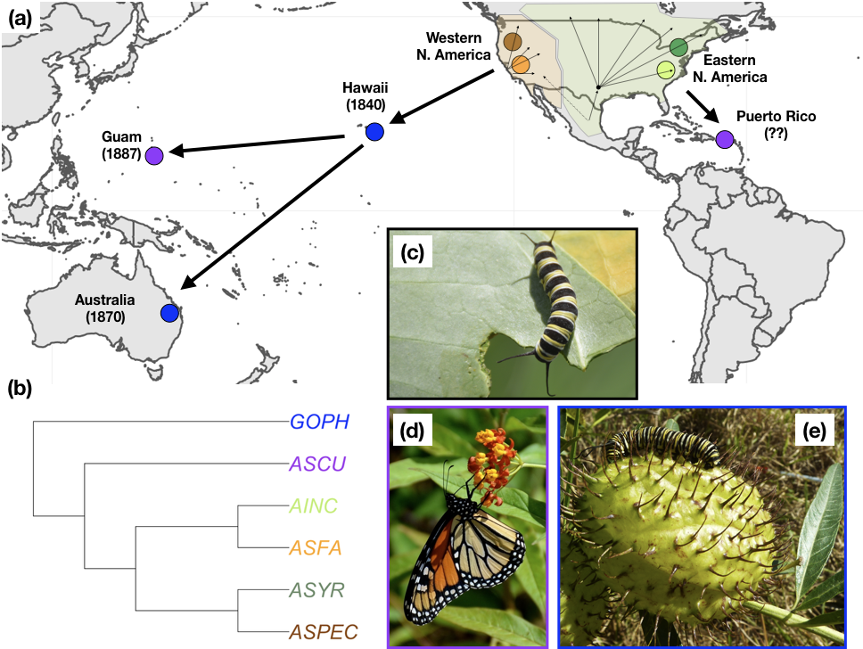

**Figure 1** – (a) Host plant associations of monarch butterfly populations around the world. Arrows correspond to routes of establishment for monarchs, with numbers in parantheses showing the earliest records of monarchs from a particular location (Zalucki and Clarke (2004)). Monarchs separately colonized the Pacific and the Caribbean from North America (Zhan *et al.* 2014), with establishment in Puerto Rico likely occuring longer ago than for Pacific populations. Colored dots correspond to primary host plant associations for each monarch population. Note that we only display the species used in this experiment and that host plant associations are more extensive than those shown here (see Table S1). (b) Cladogram of relationships among milkweed species used in this experiment built using sequences provided in Agrawal and Fishbein (2008). (c) Monarch caterpillar feeding on *C. procera* in Puerto Rico (d) Adult monarch necatring on *A. curassavica* in Guam (e) Monarch caterpillar feeding on fruit of *G. physocarpus* in Queensland, Australia.

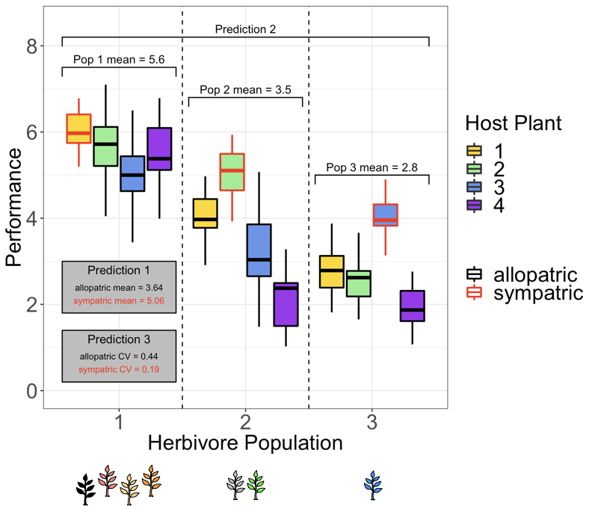 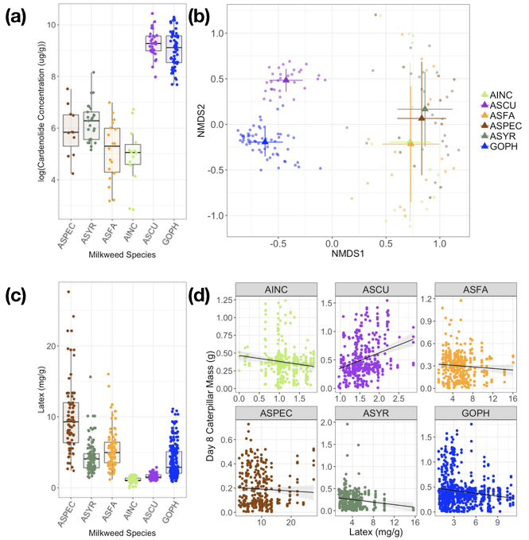

**Figure 2** – Predictions for our experiment using a hypothetical example with three herbivore populations and four host plant species. **Prediction 1**: Monarchs will show a pattern of local adaptation to host plants, with sympatric combinations of monarch population and host plant (red outlines) having higher performance than allopatric combinations (black outlines). **Prediction 2**: Monarch population 1, which has the broadest dietary breadth, should also have the highest mean performance across all host plants. **Prediction 3**: Monarchs on their sympatric host plants should show lower variation in performance than monarchs on allopatric host plants.

**Figure 3** – (a) Cardenolide concentrations for each of the six species tested. Note that concentrations are expressed as log(μg cardenolide / g dry leaf tissue). Mean concentrations ranged from as low as 0.23 mg/g in *A. incarnata* to as high as 12.12 mg/g in *A. curassavica*. (b) Nonmetric multidimensional scaling (NMDS) showing variation in the composition of cardenolides across milkweed species. (c) Latex production for each milkweed species, expressed in terms of milligrams of latex per gram of dry leaf tissue. (d) Regressions of day eight caterpillar mass on latex production across milkweed species. Note that the x-axis differs for each species.

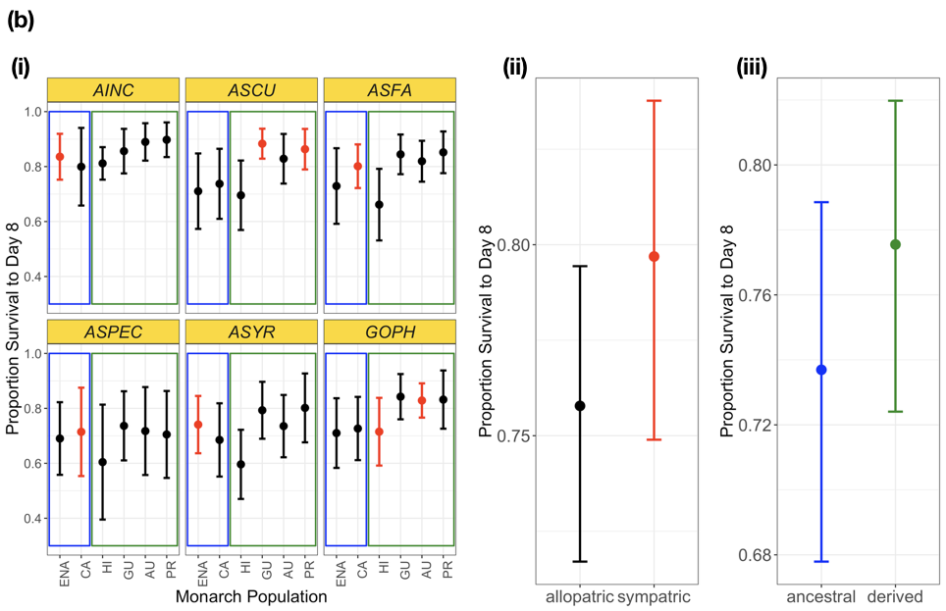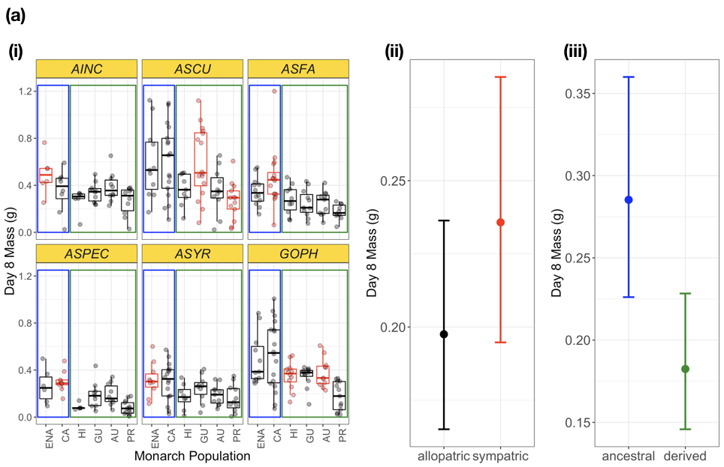

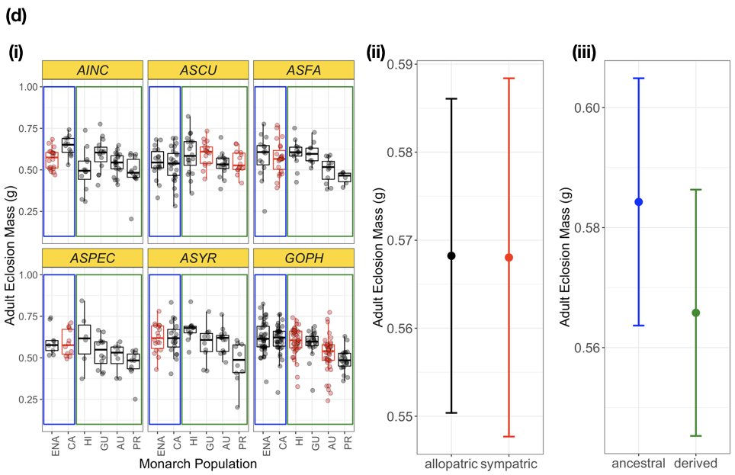 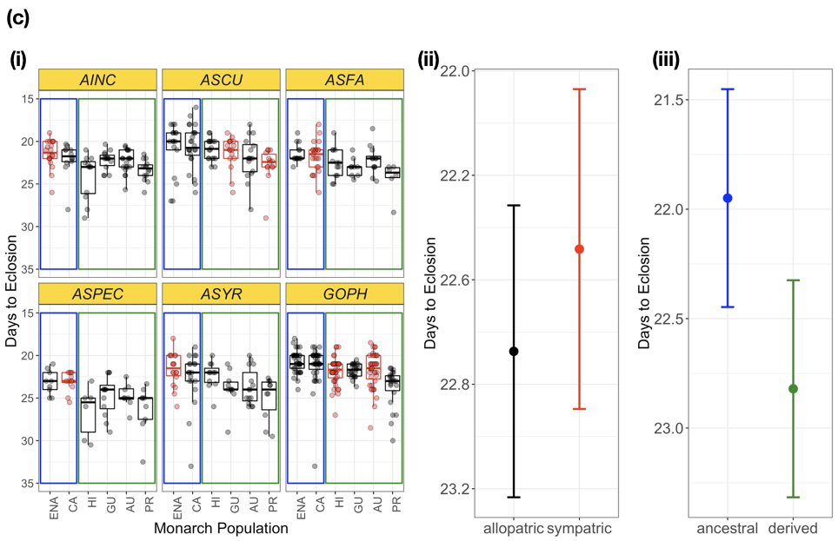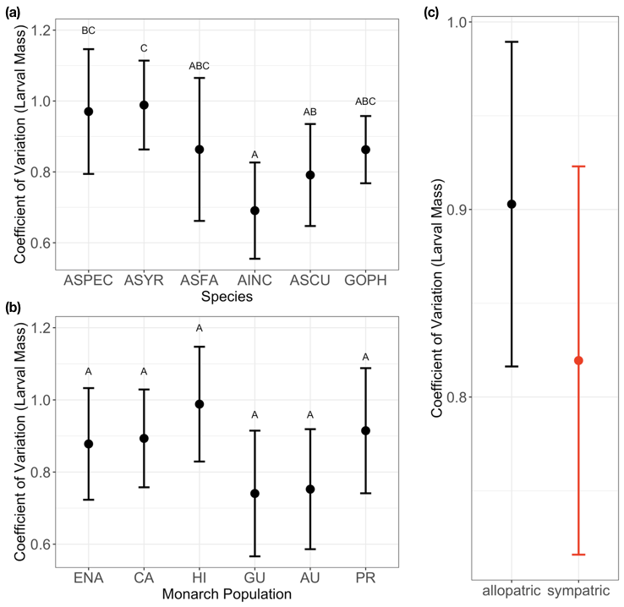

**Figure 4** – Summary of performance metrics, separated by (a) larval mass on day eight (b) larval survival on day eight (c) the number of days to eclosion and (d) mass at eclosion. In each figure, the left panel shows raw data for all monarch population x milkweed species combinations, with points corresponding to mean for single maternal families. The center panel shows the average sympatric/allopatric effect, while the right panel shows the effect of coming from an ancestral (ENA, CA) versus derived (HI, GU, AU, PR) monarch population. Note that the axis for (c) is reversed so that fewer days to eclosion corresponds to higher performance.

**Figure 5** – Coefficients of variation in monarch performance across (a) milkweed hosts (b) monarch populations and (c) sympatric versus allopatric combinations. Letters correspond to significant differences after correction for multiple comparisons. Monarchs reared on sympatric host plants had significantly lower variation in performance than monarchs reared on allopatric hosts.